**Të dhëna Personale**

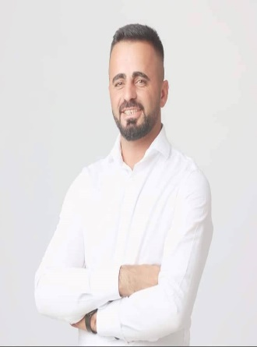

Emër/Mbiemër: Drilon MUSTAFA Datëlindja: 21.10.1991

Vendbanimi: Petkoviq, Rahovec

Vendqëndrimi: Petkoviq

Kombësia: Shqipetar

Tel: +383 49433447

E-Mail: archiline.ks@gmail.com

**Edukime dhe Trajnime**

Shkolla Mesme:

EKONOMI

SH.M.P. “Fehmi Agani” KLINE

2011-2014

__________________________________________________________________________

Studimet Universitare:

Bachelor i Arkitektures

Kolegji:AAB -Prishtine

Studimet Posdiplomike (Master)

Koligje AAB – Prishtinë

ARKITEKTURE

2019 –

_________________________________________________________________________

Trajnim:

TRAJNIM

Certifikate nga Akademia Profesionale Elita “MENAGJER BIZNESI”

04.02.2017– 01.07.2017

**Njohuri**

Të Përgjithshme:

• Office

o Word

o Excel

o Access

o Outlook

Programe Profesionale:

• AutoDesk

o AutoCad

• Tjera

|  |  |  |
| --- | --- | --- |
|  | o o | ArchiCAD Artlantis Studio |
| **Përvoja** |  |  |
| Pozita: |  | Menaxher, Udheheqes i punëve ndërtimore dhe Projektues |
| Kompania: |  | ARCHILINE  31.03.2017- |
| Pozita: |  | Projektues dhe mbikqyres |
| Kompania: |  | PMN shpk Mbikqyres i punimeve ne lemin e ndertimtaris.  11.01.2020-11.01.2022 |

___________________________________________________________________________

______________________________________________________________________________